The 12th East Asian Island and Ocean Forum (11th EAIOF)

- Date: November 13th (Thu) to 15th (Sat), 2025
- Venue: The Amami Branch, the International Center for Island Studies, Kagoshima University, Japan
- Address: The 6th floor of Tsumugi Kaikan Building, Naze Minatomachi
- 15-1, Amami City, Kagoshima Prefecture, 894-0026 JAPAN
(Google Map: 28.380974255600087, 129.4974012922864)

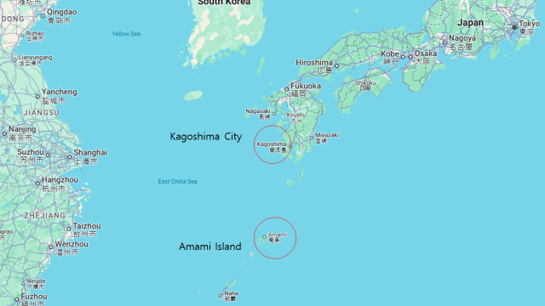

- Organizer: The International Center for Island Studies, Kagoshima University
- November 13th (Thu), 2025: Afternoon: Opening and special lectures (or ordinal sessions)
November 14th (Fri), 2025: Whole day: Sessions
- November 15th (Sat), 2025: Whole day: Excursion

- Flight Information to Amami Oshima Island (Amami Airport; ASJ) (as of December 12, 2024)
From Kagoshima (KOJ) (8-9 flights/day)
From Haneda (HND) (1 flight/day)
From Narita (NRT) (1 flight/day)
From Itami (ITM) (1 flight/day)
From Kansai (KIX) (1 flight/day)
From Fukuoka (FUK) (1 flight/day)
From Naha (OKA) (1 flight/day)

Contact person: Prof. Sota Yamamoto
e-mail: sotayama@cpi.kagoshima-u.ac.jp, sotayama1@gmail.com
Kagoshima University, Japan

